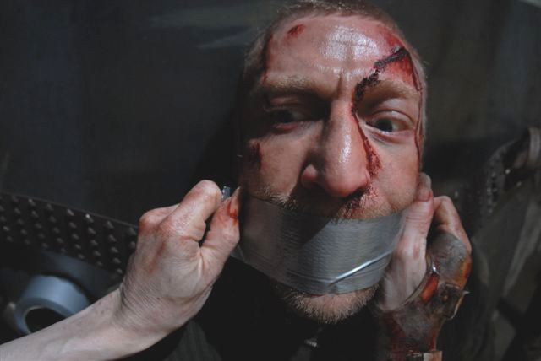
FEDERICO ZAMPAGLIONE TAKES ITALIAN TERROR TO NEW HEIGHTS

Horror isn't about the rational.

It's about those dark crevices deep in the psyche…those frights and fears that lurk in the impenetrable shadows of a damaged brain.

And Italian writer/director Federico Zampaglione creates a sinister and twisted tale of terror in SHADOW, an atmospheric and unnerving shocker that has already caught the eye of horror fans worldwide.

World premiered at Film4 FrightFest in London August 2009, SHADOW garnered Zampaglione huge critical and audience acclaim:

“Blends survivalist horror set in the wilderness, torture porn and surreal fairytale flourishes into a mad, malevolent mix that somehow feels potently fresh, SHADOW will leave audiences scratching their heads or shuddering in fear. Often both” – Jamie Graham, Total Film.

“Zampaglione finds an ingenious way to link backwoods slash-and-dash and scenes of shocking torture to broader geopolitical themes” – Little White Lies

“Where Zampaglione's rock star roots shine through is in SHADOW’s score…the soundtrack is a blazing rock score that recalls the ear-bending soundtracks of 70's and 80's italian cinema. Like all good horror films, SHADOW isn't merely there for the gore. Zampaglione successfully underpins the events of the film with a topical twist offering the theory that reality can be sicker than nightmares” – Bloody Disgusting.com

“It’s a real surprise to see a director work with such expertise. Tense and engaging, a real treat” – QuietEarth.com

“An imaginative piece of cinema that plays on your mind far more than you might expect. A driving Argento-esque rock score underlines the increasingly surreal action well and plants the film in a nostalgic 70s/80s tradition whilst the denouement brings the film right back to topicality” – Twitchfilm.net
“Federico Zampaglione's impressive horror debut will take you on a trip of twisted terror that skillfully blurs the lines of bloody reality and darkest nightmares” – Moviestar Magazine

"Zampaglione delivers a fantastic new bloodline to the Italian horror legacy,
and hopefully will continue to deliver such high quality scares" Spencer Hawken, Cinemaroll

" …the best of Italian horror tradition, in an anarchic mix of madness and pure terror" - Nanni Cobretti, i400calci.com

“Absolutely brilliant” – Alan Jones, Fangoria

“The renaissance of Italian horror” – Nocturno magazine

“A memorable tale” – Sky Movies UK

“Mortis the butcher will become one of horror cinema’s scariest and most evil looking bad guys” – Zone Horror

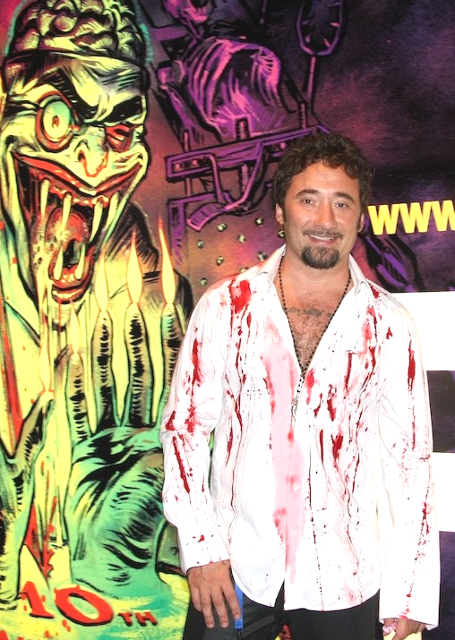
Federico Zampaglione, with his band ‘Tiromancino’, is one of the most successful singers and musicians in Italy. Their blend of pop rock has won them platinum selling albums, awards and all manner of critical praise. But life-long horror fan Zampaglione wanted another string to his artistic bow and embarked on a further exciting and talented career. After making his feature-directing debut with the black comedy Nero Bifamiliare in 2006, Zampaglione decided to finally indulge his darker passions for a follow-up movie.

SHADOW tells the strangely ethereal story of David (Jake Muxworthy), a young soldier returning from a tour of duty in Iraq, who decides to go on a mountain biking adventure in Europe to forget his battle-weary past.

In the woods he meets pretty young stranger Angeline (Karina Testa) and they team up to explore the picturesque surrounding area. Soon they learn of a mystifying local myth… a legend that will force David to face more shattering fears than he did during wartime. To meet the bloodthirsty butcher Mortis (Nuot Arquint) and to discover that reality is sicker than any nightmare.

ME AND MY SHADOW - FEDERICO ZAMPAGLIONE Q&A

- How did you get into making movies? Was it just a natural progression from your musical career?

FZ: I started directing my own band Tiromancino's video clips. I found it really exciting in terms of creativity and so I decided to shoot my first feature Nero Bifamiliare, a black comedy about a bad relationship between neighbours. I found directing natural and not so far from making music. It's just another way to express myself.

- Why didn’t you make your feature debut with a horror film instead of Nero Bifamiliare?

FZ: I’d thought about it after asking horror director Lamberto Bava to direct the video clip for our song ‘Amore Impossibile’. Devised in homage to the cult fantasy Danger: Diabolik by Lamberto’s father - legendary Italian horror director Mario Bava, it was this fruitful experience that made me more determined to direct a horror. But no one in Italy is interested in making horror films at the moment. Unless you are a brand name like Dario Argento, this isn’t a good period for the genre. Because I wanted to get into filmmaking I had to make my debut with something considered commercial and that was Nero Bifamiliare. Rudolph Gentile (the co-writer and producer of Nero Bifamiliare) liked what I had been doing with Tiromancino’s rock videos especially with respect to my story-telling abilities but would not finance a horror film. I think compromised though as I did sneak a few genre elements into the final product. It was a great learning experience and the film did well enough commercially for Gentile to ask me to work again with him. But as my dream has always been to make a horror film, I broke my contract with him and his partner – and set about making that happen.

- Where did the inspiration for SHADOW come from?

FZ: A couple of years ago I was biking with my girlfriend (Claudia Gerini), star of Nero Bifamiliare) in the woods. She was coming after me. At a certain point she disappeared after I made a turn. I started calling and I went back looking for her. I was nearly having a heart attack I was so frightened. Then I found her. She was just peeing behind a bush! I was surprised how scary it was, when someone you care for disappears all of a sudden, especially somewhere so remote and lonely like in the woods. When I got back home I was inspired and started writing the script for what would eventually become SHADOW. It’s not so different writing an album of songs to writing a screenplay. It's something you have in your mind that never leaves you - composing or scripting is a sweet obsession that can drive you crazy.

- And the urban legend elements you bring into the scenario?

FZ: That mystical area in the woods comes from something recalled from my childhood. When I was really young I used to go on vacation to my uncle's house. There was a room that was always locked, and they told me there were ghosts inside. The room was full of old furniture and was really mysterious and disturbing. I used to put my ear at the door and heard weird sounds. Maybe that room was really haunted. Maybe my uncle was hiding something inside. It was that unease I wanted to mine for the unknown territory David and Angeline discover deep in the forest, like Hansel and Gretel.

- After working for a year on the screenplay you decided to call Dario Argento for advice?

FZ: I was a huge fan of Dario’s movies like Suspiria, Deep Red and The Bird with the Crystal Plumage – they captivated me at an early age and were the reason I became such a horror fan. I got his phone number from his actress daughter Asia Argento and called him up. He was very kind to me but I’m sure he didn’t know my work at all and that he lied about knowing my music. I actually think he was waiting for me to pitch myself as soundtrack composer for his next film. When he realized I’d only written a script he told me to send him the screenplay and he’d take a look. He called me back and told me he found it interesting but that it needed more work. He gave me the strength to move forward on the project. At one point Dario even considered producing it, which would have been amazing.

- That’s when you asked your father, Domenico, to help you finesse the script?

FZ: Yes, we wrote five songs together for Tiromancino (one being ‘Amore Impossibile’) so he’s a hit-maker! I have a crazy relationship with my father and I often forget he’s my parent because we are more like school friends. The fights we’ve had, but then it’s normal for Italians to have confrontations. I respect him, he loves art in general and when I was young turned me on to such guitar heroes as Jimi Hendrix and Eric Clapton that inspired my eventual musical career. I felt a bit bogged down in the crazy SHADOW screenplay so I asked him to look at it. He’s a teacher of philosophy, which is why we developed the story more along the lines of being a war allegory. My mother freaked out as we were writing the story together, describing the horrors in her house. She’d accidentally overhear all the creepy stuff we were writing and she’d exit saying, ‘I don’t recognize you, you are not my family’…

- The ending is proving quite controversial?

FZ: So many people have told me how much the ending moved them, surprised them because they weren’t expecting it. I like it when something divides the audience, it’s a great way to make them talk about it and discuss the issues raised. Discussion is important and I worked hard at creating a combination of genre elements to make it that type of experience. Matteo Garrone (director of Gommorah) told me he was really impressed by the ending because it dealt with important contemporary issues.

- How did you cast the three main SHADOW leads?

FZ: I was surfing the internet looking for actors to play Mortis and found Swiss actor/dancer Nuot Arquint on a casting agency website. With that face I thought he would be perfect as my Death/Grim Reaper/Seventh Seal figure. He had a tiny part in The Passion of the Christ but when I met him I thought, OK, now I can make SHADOW because his dancing experience helped make Mortis’ movements really creepy. I owe him a massive thank you because we often filmed in four below zero temperatures and he was acting virtually naked. But he came through brilliantly. Karina Testa I loved in Frontiere(s) and Jake Muxworthy was a fantastic discovery by my American casting agent.

- You shot the film on location in five weeks during winter 2008 in Tarvisio, an area on the Italian/Austrian border?

FZ: The weather was diabolical and it was such a hard shoot. Luckily I knew what I was going to do every step of the way because I storyboarded every scene weeks before during sleepless nights. We shot in many hard to reach locations that even the forest rangers hired to ensure our safety warned us were dangerous! Mortis’ lair was an abandoned mine building situated 100 meters underground. It was often so damp the cameras didn’t work properly. Fortunately my producer Massimo Ferrero was a crazy horror fan too and let me do everything I wanted.

- Italian horror used to be at the forefront of the global genre. The golden age between the 1950s and 1990s gave us many great movies by Argento, Bava, Riccardo Freda, Sergio Martino, Lucio Fulci and Michele Soavi. What’s happened?

FZ: And if you were anywhere else but Italy you’d know those icons! They have never considered Bava or Freda as anything but hacks. In Italy people are very conservative and have so much prejudice towards the genre even though it kept the industry afloat for decades. Even my agent was shocked I’d consider the opportunity of making a horror film. The disappointment in taking such a career step was clear. Many thought it was a risky move and advised me against SHADOW. That’s why I decided not to think too much about the Italian market or my fan base. Italy only got the news I was launching SHADOW at Film4 FrightFest in London two days before the world premiere. We didn’t know, you’re crazy, they screamed. But I wanted to direct SHADOW because I love this kind of cinema, I wasn’t thinking about money or success but genre respect and my artistic freedom.

- You showed Dario Argento SHADOW. What did he think?

FZ: He was so thrilled and hugged me, saying he really liked it and that he was proud of me. I will never forget that moment. Being considered ‘The New Face Of Italian Horror’ is a huge responsibility, a really exciting thing but most of all it's a dream coming true.

- So do you prefer music or directing movies?

FZ: I love both. Music - it's my life and I won't stop doing it, but now I can't turn my back on directing too. So in a few words... I'm in trouble, like a man who adores both his wife and lover!

FEDERICO ZAMPAGLIONE – BIOGRAPHY

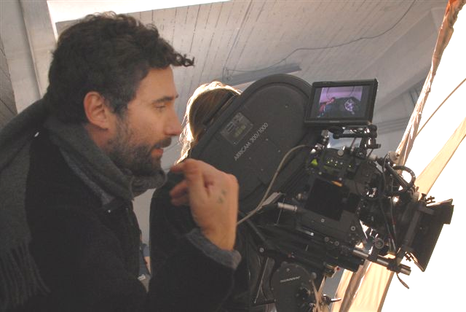
Federico Zampaglione was born in Rome in 1968. Ever since he was a young boy he was attracted to the arts. But it was music that most marked his adolescence, one spent playing cover versions of Jimi Hendrix, Cream and blues classics in clubs.

In the following years, with his band Tiromancino, he became one of the most successful singers and musicians in Italy, capturing the attention of critics and the public alike with a succession of solid chart hits. The quality and originality of the albums was distinct from the start: various music styles mixed together, giving life to a unique and unmistakable sound. His brother Francesco has been an important element of his band in creative terms right from the start. The band has received many platinum records and industry awards and their stadium concerts are always sold out

Federico has always been a great fan of the horror genre. In 2004 he asked Lamberto Bava to direct the music video for ‘Amore Impossibile’. It was devised in homage to the landmark 1968 Italian fantasy Danger: Diabolik by Lamberto’s father, the legendary Italian horror director Mario Bava. It was this defining experience that set Federico on the road to directing his own horror film.

In 2006 Federico made his directing debut with Nero Bifamiliare, a black comedy starring actress Claudia Gerini, a famous star of Italian cinema and Zampaglione’s girlfriend. It was successful with critics and at the Italian box-office so Federico began to think about his second film.

The result was to finally indulge his passion for horror: SHADOW, a dark and unnerving shocker, written with his horror fan father Domenico. Shot in November 2008 in Tarvisio, an unsettling area on the border between Italy and Austria, SHADOW features an international cast including Karina Testa (Frontière(s) and Jake Muxworthy (Borderland).

Producer Massimo Ferrero courageously decided to give Federico creative freedom on the project. Even though there are some particularly violent and bloody scenes in SHADOW, Ferrero believed in Federico’s artistic vision to finally return extreme vision and international impact to Italian horror, something that has been missing in recent years.

Straight after shooting interest surrounding the film intensified and the masters of Italian horror - Dario Argento, Lamberto Bava and Ruggero Deodato - fell in love with it, considering Federico in their class as one of the new leaders of horror.

SHADOW has also created much interest abroad and premiered at the prestigious Film4 FrightFest in London. The film also was the only Italian production chosen to participate in the 42nd Sitges Film Festival where it was screened in the new auditorium with nearly 1400 seats, where people flocked even on very late night show. Other horror film festivals in Europe – Razor Reel Fantastic Film Festival in Bruges and Courmayeur Noir in Festival and Science+Fiction Festival in Trieste - and worldwide – Buenos Aires Rojo Sangre (Argentina) and the Cinefantasy Festival (Brazil) – are fighting over the film, defining it the “renaissance of Italian horror”.

Federico has a couple of new horror projects he will be developing shortly. One set in medieval times he calls “frightening and very violent”.

www.shadowfilm.net

contact: press@shadowfilm.net

